Assignment 3.03: Capacitors
- Two places of metal are separated by a distance of 1 mm. Each of the plates has a surface area of 0.5 m². The plates are separated by empty space.
  - What is the capacitance of the capacitor?

  - What is the charge that builds up on the capacitor if a voltage of 120 V is applied?

- A capacitor is made of two parallel plates with an area of 0.25 m². They are separated by a distance of 1x10⁻⁵m, and separated by a layer of rubber, with dielectric constant κ = 7.
  - What is the capacitance of the capacitor?

  - The capacitor is connected to a 6V battery. What is the magnitude of the electric field inside the capacitor?

- A parallel plate capacitor is made from two disks of metal, of radius r=15 cm. The plates are separated by a layer of paper, κ = 2.3. If the capacitance of the capacitor is 4.25 μF, how thick is the layer of paper?

- A capacitor has is rated at 4 mF. What voltage would need to be applied to the capacitor in order to store 1 C of charge?

- A capacitor stores a charge of 0.275C when its potential difference is 25V. The plates are separated by a distance of 4x10⁻⁴ m. Assuming there is empty space between the plates, what is the area of the plates?

- A variable capacitor can be made by placing alternating rotating and stationary metal “fins,” as seen in the diagram below. The rotating fins are connected to a knob that can be rotated, either by a motor or by hand. In a clear, coherent, and well-written paragraph, explain how moving the rotating fins can cause the capacitance of this device to change. Your answer may include formulas and drawings as needed, but should consist primarily of well written English.
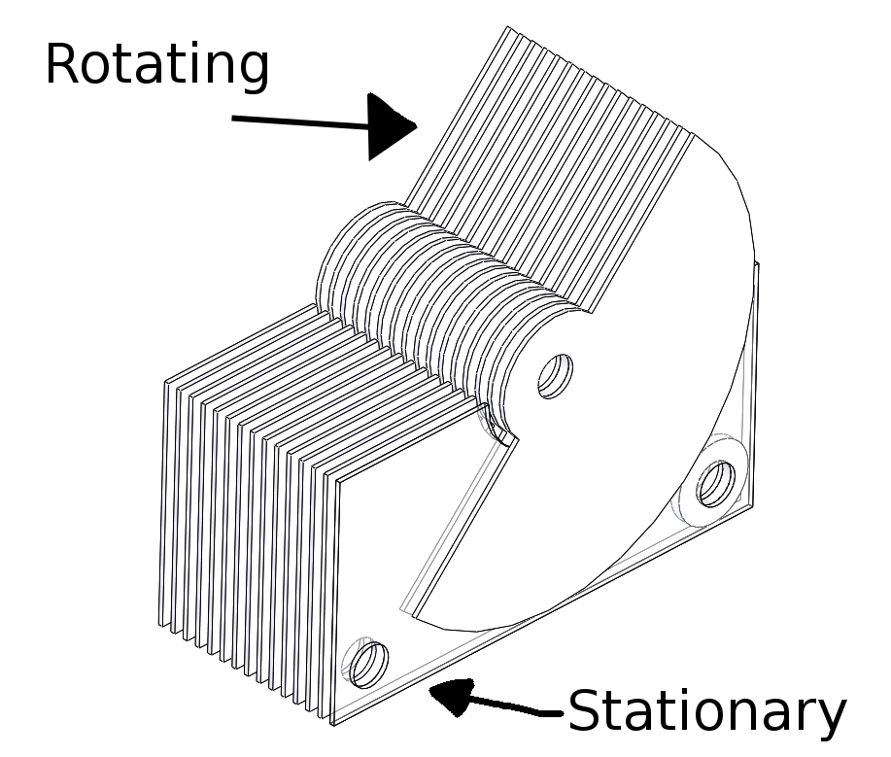

Diagram by Michael Struzik, https://www.n1fd.org/2016/12/13/homebrew-variable-capacitor/

